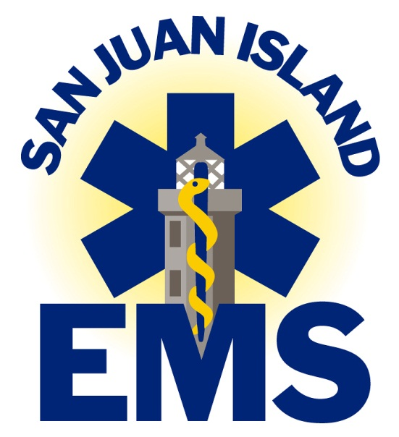

APPLICATION FOR EMT

PO Box 2178
1079 Spring Street
Friday Harbor, WA 98250-2178

www.SanJuanEMS.org

From the Office of the Chief
Jim Cole, MA, FP-C, NREMT-P, CEMSO, CMTE

Dear EMT Applicant:

I applaud your desire to investigate becoming an EMT with San Juan Island EMS. Our agency has over 30 years of providing EMS to the Town of Friday Harbor, San Juan Island and the islands of Brown, Stuart, Johns, Speiden, Pearl and Henry. We function as a municipal third service 9-1-1, tax supported EMS system under the San Juan County Public Hospital District No. 1. We serve the residents and visitors of our district as well as the waterways and other non-ferry served islands of San Juan County when requested. We operate three advanced life support ambulances, several fixed wing air ambulances and perform marine rescue in conjunction with the San Juan County Sheriff’s Office.

We operate a nationally recognized rural advanced life support agency with over 40 Emergency Medical Technicians (EMTs), four paramedics, Flight Registered Nurses, and other paid administrative and education staff. Our professional EMTs are the backbone of our system and are given greater amounts of education and training than most other agencies.

The packet that you have in your hand will help you navigate the application process. Please read it carefully, complete it as quickly and accurately as possible, and return all requested materials to us in person at the address on the cover. Someone is generally in the office Monday to Thursday during normal business hours. Suitable applicants will be scheduled for an interview. The process is highly competitive. Those accepted will need to pass a criminal background and driving check, and physical and drug screening exam provided by our agency before final acceptance. Questions about this process can be directed to Weyshawn Koons at wkoons@sanjuanems.org or by phone.

Candidates will be selected based on multiple criteria including but not limited to the completed application materials, geographical location, ability to respond to calls, and face to face interviews.

For further information about us, please go onto the web at www.SanJuanEMS.org and talk to your friends and neighbors. We wish you success in your application to San Juan Island EMS.

Sincerely,

Chief Jim Cole

Applicant Name:_______________________________________________

Checklist (To Be turned in with Application)

- Meet Minimum requirements
- Completed Application with signatures and witness signatures
- Copy of National Registry EMT Certification
- Copy of Washington EMT Certification (if currently certified)
- Copy of Course Completion Certificate
- Copy of High school diploma or GED
- Copy of Valid Social Security Card
- Copy of Washington State Driver License
- Completed Background Check Waiver with witness signatures

Minimum Requirements to Apply

We value your time and interest. You will need to meet the following criteria:
- 21 or older (due to insurance requirements).
- High school diploma or GED.
- Not become a volunteer with any other public safety agency during your first year of orientation because of the high extensive training requirements.
- Be able to do a physically and emotionally difficult job of providing care to acutely ill and injured people, in dangerous situations, requiring quick and clear thinking with physical dexterity and strength.
- Full-time, permanent resident of the Town of Friday Harbor or San Juan Island.
- Native or naturalized citizen of the United States.
- Valid Social Security Number.
- Washington State Driver License with less than 6 points and no convictions for DUI or Reckless Operation in the past 6 years.
- No felony or misdemeanor convictions that would prevent you from becoming registered with the State of Washington.
See http://www.doh.wa.gov/hsqa/emstrauma/initcert.htm for these requirements.
- Free from addiction to any prescribed, recreational, and/or illegal drugs or substances. Zero tolerance policy.
- Complete ALL training programs as outlined in the following pages, including meeting all ongoing continuing education and training requirements.
- Respond to a minimum of 25 calls per quarter (every three month period) which is approximately two calls per week and a minimum of 100 calls per year.
- Submit to a physical examination including drug screening exam provided at the cost of the district.
- Undergo a thorough criminal background and driver check through available law enforcement inquiries.
- Become certified as a Wilderness EMT, and other required orientation and training within 12 months of employment.
- Possess a genuine caring for the residents and visitors in our community and act professionally and with concern for people’s safety and privacy at all times.

I recognize that this is an application for entrance into the EMT class only and not an application for employment or volunteering with San Juan Island EMS. I agree to pay for the cost of my books before class begins. Having read the above, I, __________________________________ agree to fulfill the requirements and submit to the terms of reimbursement for self-selected early termination.

_________________________________________ ______________________________________________
Signature of Applicant Witness to Signature
Date ______________________________ Date ___________________________________

Basic Demographic Information

TODAY’S DATE ________________________________________________

NAME _______________________________________________________________________________________
LAST FIRST MIDDLE

ADDRESS____________________________________________________________________________________
MAILING
___________________________________________________________________________________
Physical Address (IF DIFFERENT)

EMAIL ADDRESS:

TELEPHONE_____________________________ DATE OF BIRTH ________/________/________

SOCIAL SECURITY NO.____________________________________________________________________
(Attach a legible copy)

CURRENT WA STATE DRIVERS LICENSE NO._________________________________________
(Attach a legible copy)

Do you have any physical or psychological problems that could affect your ability to perform the work of an EMT? YES NO

WOULD YOU BE ABLE TO RESPOND TO AID CALLS:

DAYS ONLY_________ NIGHT AND DAY___________

NIGHTS ONLY_______ CERTAIN DAYS OF THE WEEK__________

Do you have any past medical experience? If yes, please explain.

Are you currently affiliated with any other public safety agency or voluntary group(s)?

In 100 words or less, tell us why you want to become an EMT with San Juan Island EMS.

Criminal/Driving Background Waiver and Release

TODAY’S DATE : ______________________

I, _______________________________________________________________________ do hereby authorize San Juan Island EMS/San Juan County Public Hospital District No. 1 to obtain complete driver and criminal record histories and any other information concerning my previous employment or volunteering. This may include but not limited to WATCH, NCIC, San Juan County Sheriff Records, Military Discharge Records, State and Federal records, employment records, volunteering records, and educational records.

I hereby release all parties and persons connected with any request for information from all claims, liabilities, and damages for whatever reason arising out of such information gathering or information received.

NAME _______________________________________________________________________________________
LAST FIRST MIDDLE

ADDRESS____________________________________________________________________________________
MAILING
___________________________________________________________________________________
Physical Address (IF DIFFERENT)

TELEPHONE_____________________________ DATE OF BIRTH ________/________/________

SOCIAL SECURITY NO.____________________________________________________________________
(Attach a legible copy)

CURRENT WA STATE DRIVERS LICENSE NO._________________________________________
(Attach a legible copy)

________________________________________ _________________________________________
Signature of Applicant Witness to Signature
Date ______________________________ Date ________________________________

